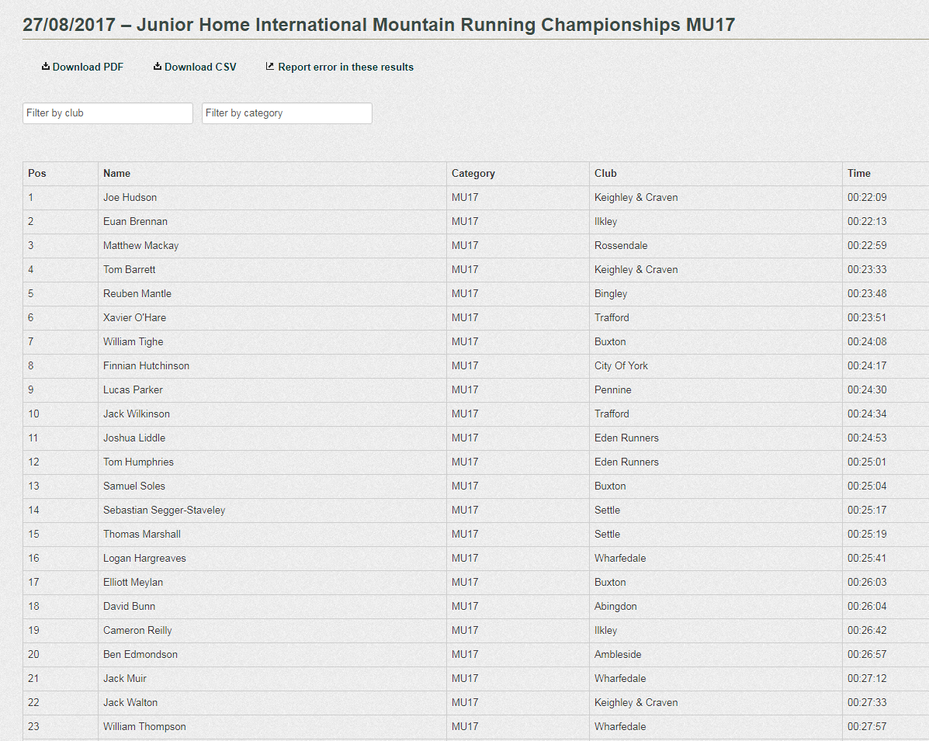

http://www.fellrunner.org.uk/results.php?id=4409

Joe Hudson & Tom Barrett qualify for England “A” team for Home International on same course on Sunday 17th September.
Good run too from young Jack Walton, fresh back from his holiday in Mexico!

