OAKWORTH HAUL FELL RACE - ROUTE
Saturday 7th July 2012

Oakworth Gala Field,
Oakworth ,
KEIGHLEY 5.5miles; 650 ft climb

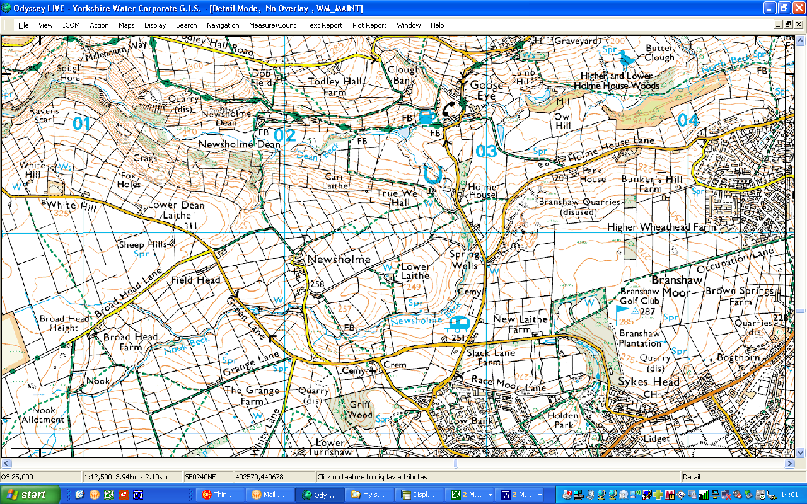
Start/Finish
Oakworth Gala Field, off Lidget (Main Road) Oakworth
From this point return same way to start

Keighley

